Instructions for Site Staff-Completing DocuSign
Transcript
Directions:
Now that your member has completed their portion of the DocuSign paperwork and the packet has been forwarded to you by DocuSign, it is your turn to complete your portion of the paperwork and upload enrollment documents.
- You will receive an email from DocuSign requesting that you need to review and complete documents.

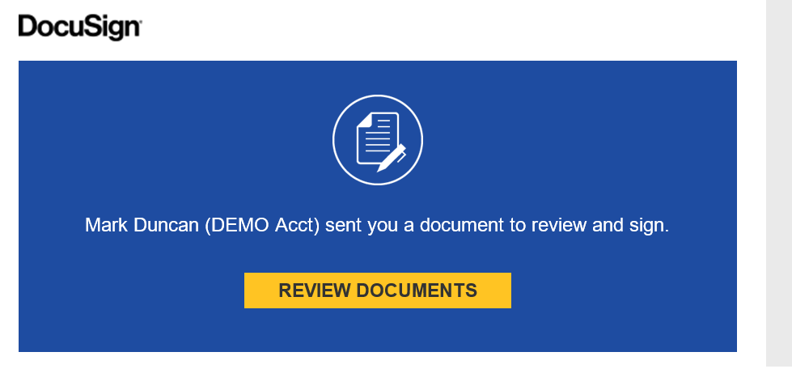
- Click on “review documents” and the DocuSign documents will load.

- There will be a message at the top, explaining the DocuSign process and to complete all fields and not to use the fax function if offered, as this has caused technical problems in the past.

- Also, read the Electronic Record and Signature Disclosure and check the box if you accept.

- Just a quick note on how to navigate through DocuSign. If for some reason you cannot complete the DocuSign paperwork in one sitting go to the top of the document under Other Actions and click on Finish Later.
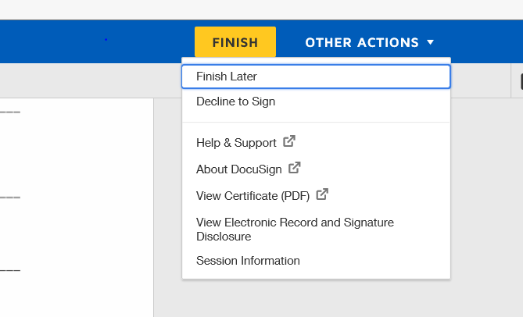
  - If you ever click "start" button at the top of the document you will automatically be taken to the first information field you need to complete. Once you add the required information on each page, you will click the "next" button. It will take you to the next informational field you need to complete.

- Before can complete this document, you will need to have gathered electronic copies of the member’s AmeriCorps application, references, and signed Position Description Form, as you will be required to upload all of these documents at this time.

- When you open the DocuSign paperwork, the first document you will need to complete is the “Sponsoring Organization Form”. This form provides us with information about the mailing addresses of your main organization location and the member’s service site, and identifies the people who will be points of contact for quarterly reporting and other program requirements.
  - Note that when you are specifying the Primary Project Site Staff for the AmeriCorps Member it must match the Primary Project Site Staff that was listed on the member’s Position Description Form. If it does not match, we will need to follow up for corrections before the member can be enrolled.
  - At the bottom of the form, you will need to identify the individual in your organization who will be submitting quarterly reports for your AmeriCorps project—this does not need to be the same person as the Primary Site Staff identified above if there is somebody else with your organization who is responsible for tracking and entering performance measurement data. The only requirement for this field is that the individual you list cannot be an AmeriCorps member.

- Once you’ve completed the Sponsoring Organization Form, you will be taken to the “Site Staff Certification and Upload” page.
  - Please review and initial the information on Background checks and references. Then attach copies of the AmeriCorps application and references,
    - To upload documents you will need to click on the yellow paperclip icon for each box, then select the file you want to attach from your computer. This can take a moment to load, so please be patient if it doesn’t appear right away.
    - We also want to draw your attention to the member references – regardless of whether your member is returning to service or brand new, we require all members to have two reference checks completed before they can be enrolled.
      - Please ensure that you have completed two separate reference checks for your member prior to starting the enrollment process to avoid any issues with delaying their start date.

- Next you will review the Member Service Agreement or MSA. It is important that you read the entire Member Service Agreement before signing the final Acknowledgement Page as this is the contract that outlines your AmeriCorps member’s rights and responsibilities with the WSC/WRC program. You will also initial that you will use the MSA to guide your oversight.
  - Please verify that the term of service listed on the Acknowledgement Page matches the term you were selecting—if it does not, please contact your Program Coordinator immediately to correct this.
  - Once you have signed the Acknowledgement Page, you will be prompted to upload your member’s signed Position Description Form—this will be the same process you followed when uploading the other documents above. If you don’t have this form, you can find it on our website forms page. You will need to fill out this form and both you and the member will need to electronically sign it before you can upload it to DocuSign. If you have any questions about completing this form please contact your WSC/WRC coordinator.

- Once you have completed all of these steps, please take one more moment to review the documents for accurate completion, then click the “Finish” button.

- Then click finish at the top of the screen. If you missed filling out any forms, or had errors DocuSign will take you to those sections of the document. Finally, when all is complete accurately, click on finish at the top of the DocuSign enrollment packet and the document is now automatically emailed to the next person who needs to fill out their section of the enrollment paperwork, which should be WSC staff.

- A pop up box may then appear asking to create an account and save your document. You do not need to do so, as you will receive an email copy once everyone has signed.

- This will finalize your member’s enrollment paperwork, and submit it to the WSC/WRC office for review. As mentioned elsewhere in these training videos, this does not mean that your member is enrolled, as there may be additional corrections required after review. Your Program Coordinator will let you know if this is the case, or if your member is cleared for enrollment.

