K12 - AVID 19/20
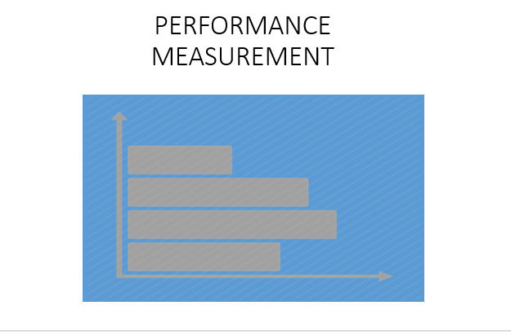
Hello, my name is Robert Brader, the WSC Performance Measurement Coordinator. In this session, I’ll be discussing K12 AVID;

As an AmeriCorps intermediary, WSC is required to ensure that all Service Sites
- Establish, track, and assess performance measures for their programs.
- Establish ambitious and realistic performance measures in consultation with WSC
- Ensure that programs under our oversight collect and organizes performance data on an ongoing basis, at least quarterly
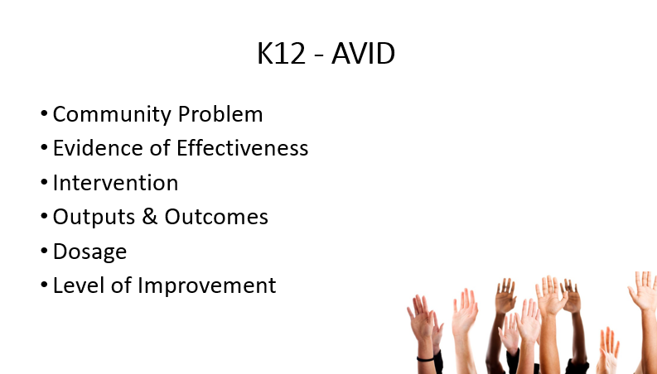
In this session, I’ll discuss the community problem, the evidence to support the intervention, the intervention itself, how to track the output & outcomes, Dosage level requirements and the definition of improvement.
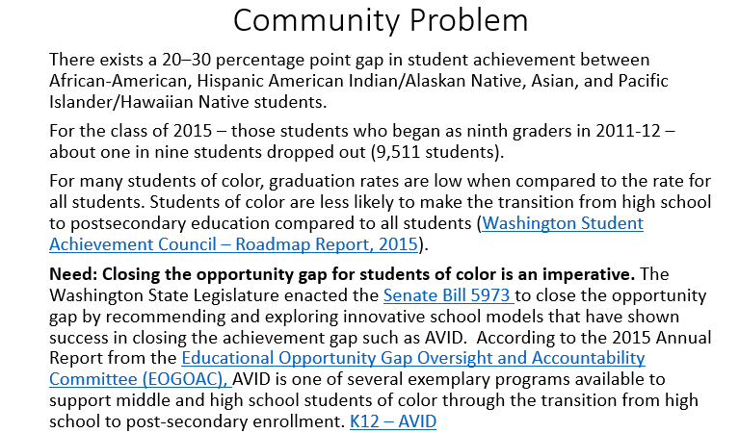
In today’s public schools, success for students of color is too often elusive. Our society still bears the legacy of a long history of racism, exclusion and low expectations for students of color. This persistent challenge is deeply harmful to our community and country. Lower rates of high school graduation lead to less employment, higher rates of incarceration, ill health, substance abuse, and intergenerational poverty. While poverty can compound the opportunity gap for students of color, we must acknowledge that our middle and upper income students of color are still in the opportunity gap. Far too many students are in demographic groups that are overrepresented in measures such as school disciplinary sanctions; failure to meet state academic standards and failure to graduate.
Washington Student Achievement Council – Roadmap Report, 2015
Senate Bill 5973
Educational Opportunity Gap Oversight and Accountability Committee (EOGOAC),
K12 – AVID

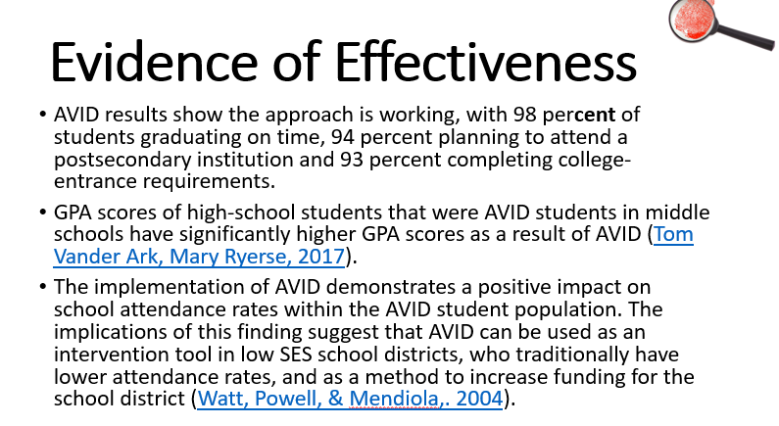
Key Findings

- Students from underrepresented ethnic and linguistic backgrounds who participated in AVID enrolled in college in numbers exceeding the local and national averages.
- Latino AVID graduates are going on to four-colleges at two times the national average.
- African American graduates are going on at 1.5 times the national average.
- AVID students are staying in college once enrolling; 89% are enrolled after 2 years.
- Among the most visible social supports in AVID classrooms is the teaching of test-taking strategies, note-taking, and studying strategies.

Tom Vander Ark, Mary Ryerse, 2017
Watt, Powell, & Mendiola,. 2004

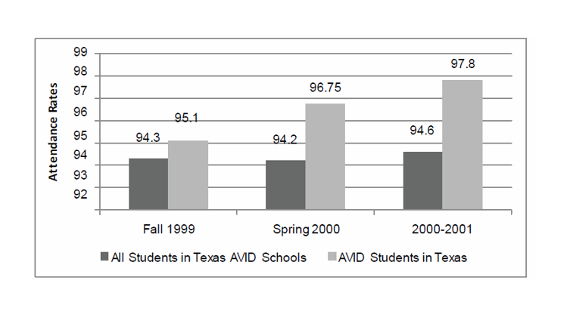
AVID as it was designed also shows a positive impact on student attendance. Two early studies on AVID in Texas looked at the attendance rates of AVID students compared to the rates of all students in their schools (a total of 26 middle and high schools implementing AVID at that time). From the 1999-2000 to the 2000-2001 school year, AVID students in Texas AVID schools showed attendance rate increases from 95.1% to 97.8%, while all students in those same schools remained steady at just over 94.2% to 94.6%.
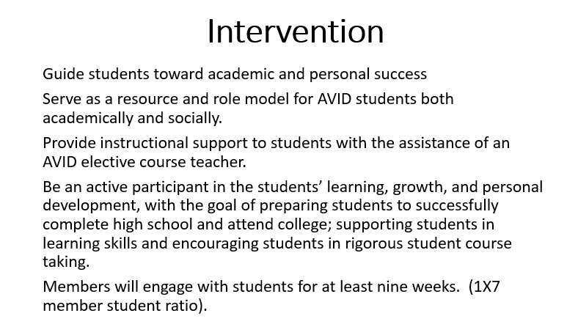
Guide students toward academic and personal success
Serve as a resource and role model for AVID students both academically and socially.
Provide instructional support to students with the assistance of an AVID elective course teacher.
Be an active participant in the students’ learning, growth, and personal development, with the goal of preparing students to successfully complete high school and attend college; supporting students in learning skills and encouraging students in rigorous student course taking.
Members will engage with students for at least nine weeks. (1X7 member student ratio).
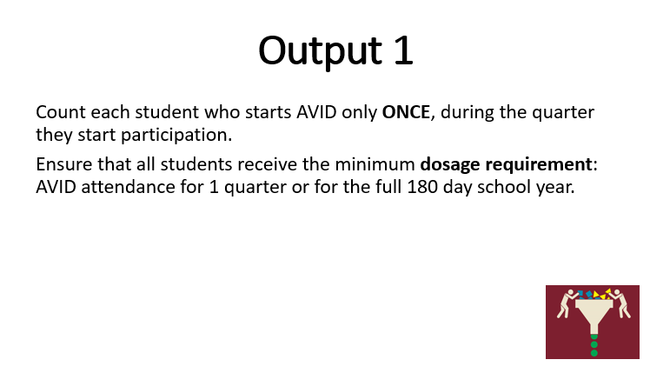
Count each student who starts AVID only ONCE, during the quarter they start participation.
Ensure that all students receive the minimum dosage requirement: AVID attendance for 1 quarter or for the full 180 day school year.
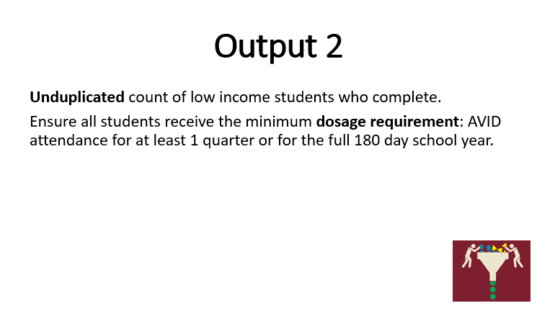
Participating students must be enrolled in a school where the majority of students are eligible for free or reduced lunch or enrolled in a school where the majority of students are eligible for free or reduced lunch; may or may not actually be accessing free/reduced lunch.

Completion occurs when student eithers meets a minimum requirement of at least 1 quarter or for the full 180 day school year.
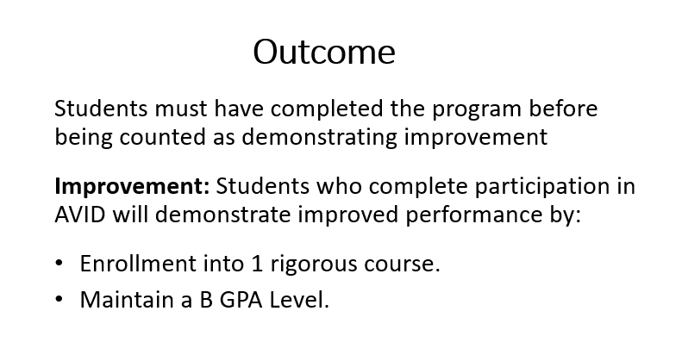
The first step in students achieving credentials for readiness is increased enrollment in rigorous courses.

- Enrollment into 1 rigorous course.
- Maintain a B GPA Level
