Services to live Independently 19/20
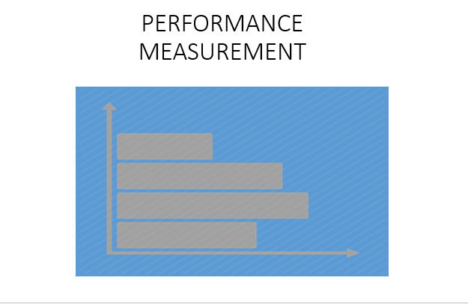
Hello, my name is Robert Brader, the WSC Performance Measurement Analyst. In this session, I’ll be discussing Services to live Independently.

- As a CNCS intermediary, WSC is required to ensure that all Service Sites
- Establish, track, and assess performance measures for their programs.
- Establish ambitious performance targets
- Ensure that programs under our oversight collect and organizes performance data on an ongoing basis using a data collection strategy
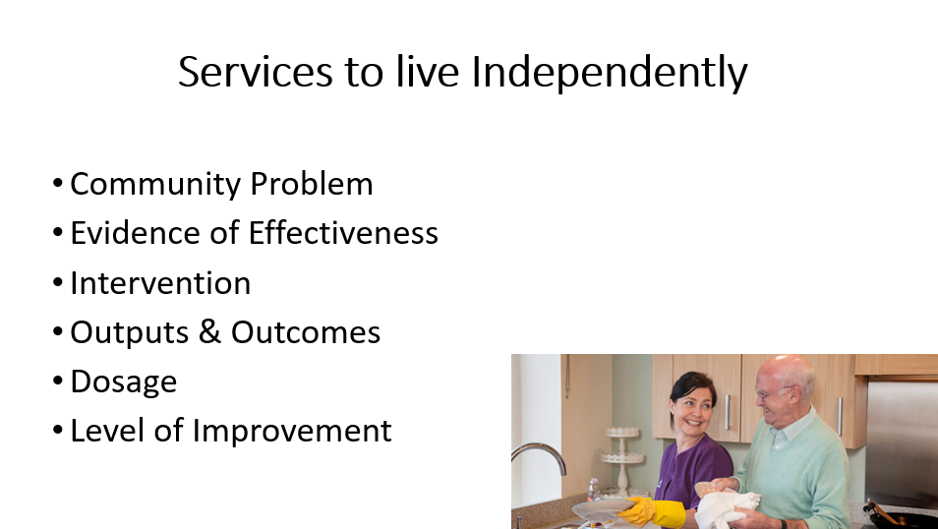
In this session, I’ll be covering topics such as the community problem, Evidence of Effectiveness, Intervention and measuring outputs and outcomes.
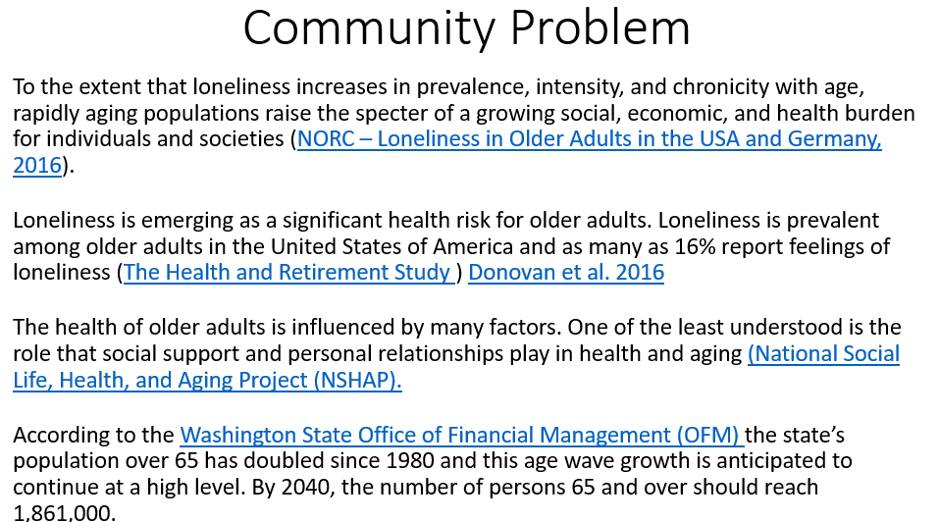
As the silver tsunami continues to grow, studies show that older adults prefer to remain living independently in their homes, and 75% of those needing care rely on “informal care” from family caregivers as opposed to institution care (Institute for Health and Aging) The research links loneliness and social isolation with chronic conditions and cognitive decline.

NORC – Loneliness in Older Adults in the USA and Germany, 2016
The Health and Retirement Study
Donovan et al. 2016
National Social Life, Health, and Aging Project (NSHAP)
Washington State Office of Financial Management (OFM)
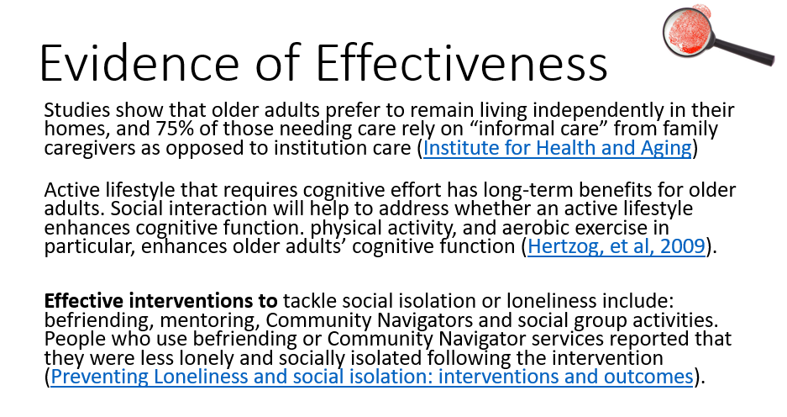
The research about loneliness and social isolation has developed incrementally over the last two decades, beginning to build an evidence base of what works for whom…There exists a wide variety of interventions that show that befriending activities helps to improve social isolation.

Institute for Health and Aging
Hertzog, et al, 2009
Preventing Loneliness and social isolation: interventions and outcomes

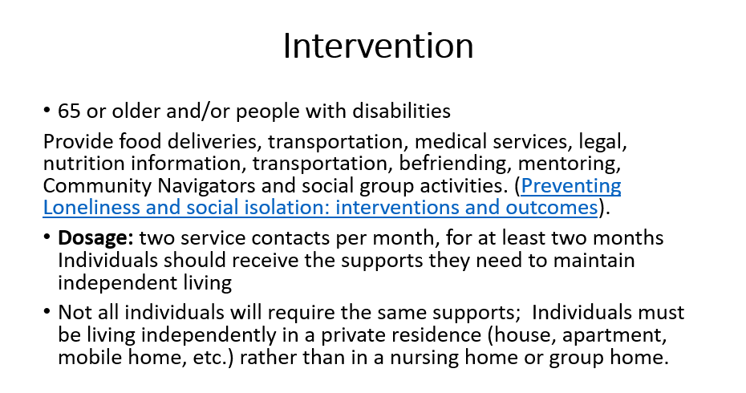
Members will provide food, transportation, or other services for at least two service contacts per month, for at least two months to support seniors (over 65) and people with disabilities defined as an individual with a physical or mental impairment that substantially limits one or more major life activities. Individuals should receive the supports they need to maintain independent living; not all individuals will require the same supports; some individuals may need food deliveries, legal and medical services, or perhaps nutrition information or transportation. Individuals served must be living independently in a private residence rather than in a nursing home or group home. The interventions should primarily focus on social isolation or loneliness such as befriending, mentoring, Community Navigators, social group schemes with an aim toward increasing their social interaction and community involvement, taking up or going back to hobbies and participating in wider community activities. When planning services to reduce social isolation or loneliness, strong partnership arrangements need to be in place between organizations to ensure developed services can be sustained.
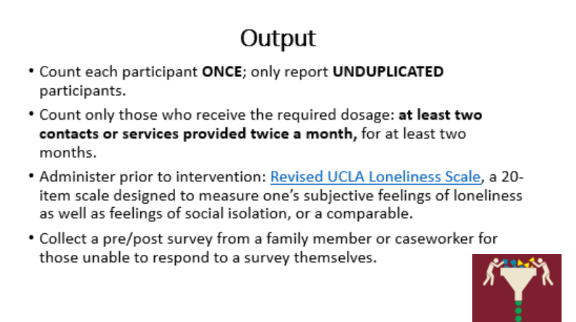
Report the UNDPULICATED number of older adults (65 and over) or individuals with disabilities receiving services that allow them to live independently. Count each participant ONCE; only report UNDUPLICATED participants. If two eligible individuals live at the same address, they should both be counted. If an eligible individual lives with someone else who is not eligible, the non-eligible individuals in the household should not be counted.

Count only those individuals who receive the required dosage: at least two contacts or services provided twice a month, for at least two months.

WSC recommends that project sites administer the Revised UCLA Loneliness Scale, prior to service. The UCLA Loneliness scale is a 20-item scale designed to measure one’s subjective feelings of loneliness as well as feelings of social isolation.

Revised UCLA Loneliness Scale

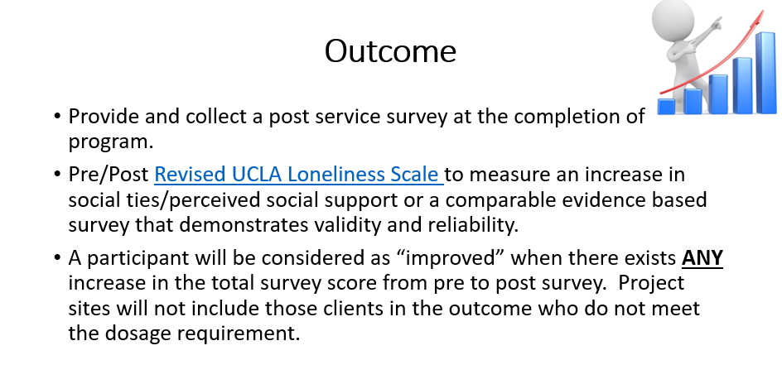
Report the number of individuals who report an increase in subjective feelings of loneliness as well as feelings of social isolation.

A participant will be considered as “improved” when there exists any increase in the total survey score from pre to post survey. Project sites will not include those clients in the outcome who do not meet the dosage requirement.

Project sites should collect a post service survey at the completion of program and compare with pre service survey.

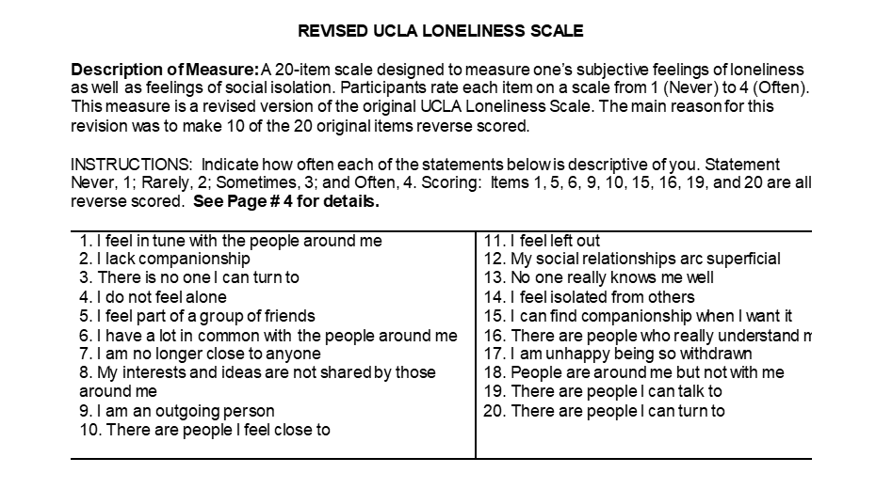
The 20-item UCLA loneliness Survey is measured on a Likert 4-coded response scale ranging from 1 (never) to 4 (often). Each of the coded responses include a numerical value that will be used to measure the condition under investigation. Items 1, 5, 6, 9, 10, 15, 16, 19, 20 are all reverse scored, to keep scoring continuous. The survey score will be calculated by summing all of the questions.
