Food Security 19/20
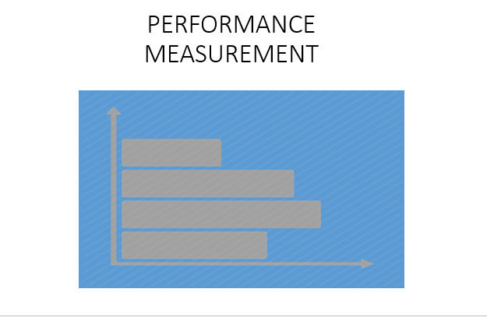
Hello, my name is Robert Brader, the WSC Performance Measurement Coordinator. In this session, I’ll be discussing Food Security, but first a little bit about performance measures.

Performance measures are measurable indicators of a program's performance as it relates to member service activities. Performance measurement is the process of regularly measuring the services provided by your program and the effect your program has in communities, in the lives of members or community beneficiaries. The main purpose of performance measurement is to strengthen your AmeriCorps program, to foster continuous improvement and to identify best practices and models that merit replication. Performance measurement will also help to identify programmatic weaknesses that need attention.

As a CNCS intermediary, WSC is required to ensure that all Service Sites
- Establish, track, and assess performance measures for their programs.
- Establish ambitious and realistic performance measures in consultation with WSC
- Ensure that programs under our oversight collect and organizes performance data on an ongoing basis, at least quarterly
- Ensure that programs under our oversight track progress toward meeting performance measures;
- Ensure that any program under our oversight corrects performance deficiencies promptly; and fairly present the results in reports to WSC.
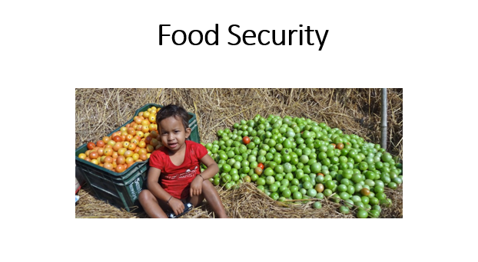
In this session, I’ll be covering topics such as the community problem, Evidence of Effectiveness, Intervention and measuring outputs and outcomes.

We need to increase Services to improve food security. Food insecurity and long-term hunger stem from poverty and a lack of reliable income sources, making the homeless population the most vulnerable.

This performance measure is specifically about long-term food security, so it would not apply to summer programs that are filling a summer gap. Filling a summer gap would not translate to increased food security a few months out. If you are a summer program working on this issue, you can create and enter your own applicant-determined measure. Also, it is not limited to activities that are educational in nature.
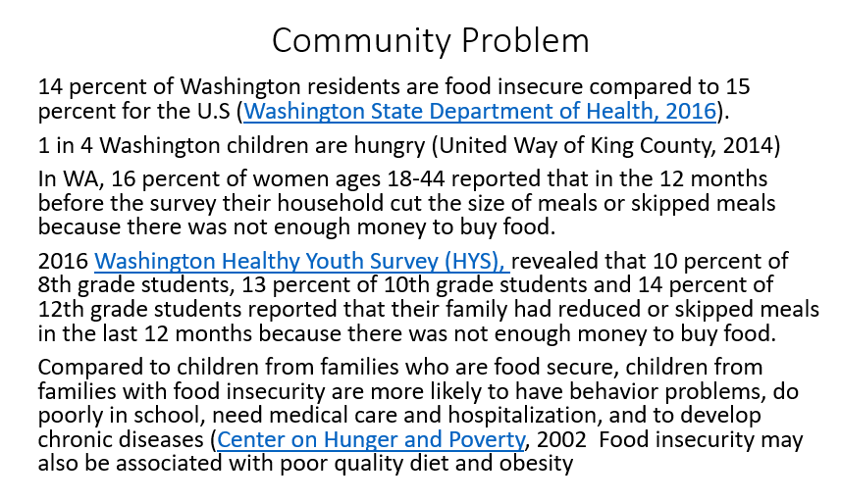
Food security is out of reach for too many Washington families. In 2013 about 14 percent of Washington residents were food insecure and 6 percent had very low food security compared to 15 percent and 6 percent for the U.S (Washington State Department of Health, 2016). 1 in 4 Washington children are hungry (united Way of King County, 2014). Based on 2011 survey data from the Behavioral Risk Factor Surveillance System (BRFSS), among Washington women ages 18-44, about 16 percent reported that in the 12 months before the survey their household cut the size of meals or skipped meals because there was not enough money to buy food. Of those women, about 31 percent reported this happened almost every month. In the 2014 Washington Healthy Youth Survey (HYS), revealed that 11 percent of 8th grade students, 13 percent of 10th grade students and 14 percent of 12th grade students reported that their family had reduced or skipped meals in the last 12 months because there was not enough money to buy food.

children from families with food insecurity are more likely to have behavior problems, do poorly in school, need medical care and hospitalization, and to develop chronic diseases (Center on Hunger and Poverty, 2002 Food insecurity may also be associated with poor quality diet and obesity
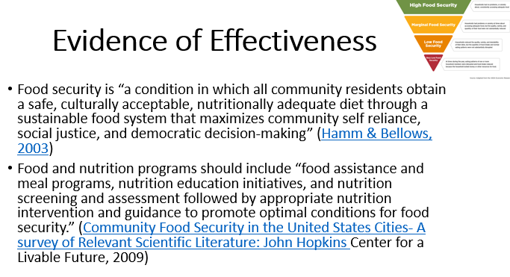
The Evidence points to a multifaceted approach. The multidisciplinary nature of the interventions necessary to build community food security in economically deprived neighborhoods requires emphasis. The John Hopkins material presents a range of community and institutional interventions, as well as resources from which details of further interventions can be accessed.

Community Food Security in the United States Cities- A survey of Relevant Scientific Literature: John Hopkins

Hamm & Bellows, 2003
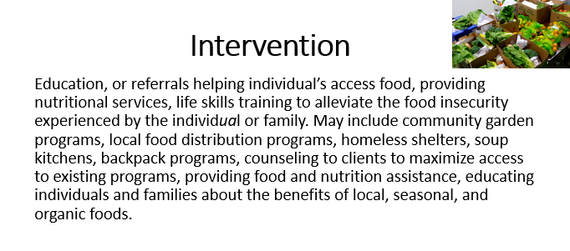
Members and the volunteers they recruit will provide evidence-informed support to qualifying individuals for at least four interactions during the AmeriCorps term of service. Qualifying individuals will be those identified as food insecure on the USDA’s Household Food Security Pre-Survey. Support services can include education, or referrals helping individual’s access food, providing nutritional services, life skills training to alleviate the food insecurity experienced by the individual or family. May include community garden programs, local food distribution programs, homeless shelters, soup kitchens, backpack programs, counseling to clients to maximize access to existing programs, providing food and nutrition assistance, educating individuals and families about the benefits of local, seasonal, and organic foods. This intervention strategy requires an engagement with the individual in person, by phone, or through a web- interface for at least four ten minute interactions during the AmeriCorps term of service. Pamphlets, brochures, or web-based information that does not involve a human interaction is not sufficient. Programs may not focus their services solely on providing referrals to Federal assistance programs. WSC recommends that WSC project sites begin to consider increasing the participant dosage as a way to augment positive change.
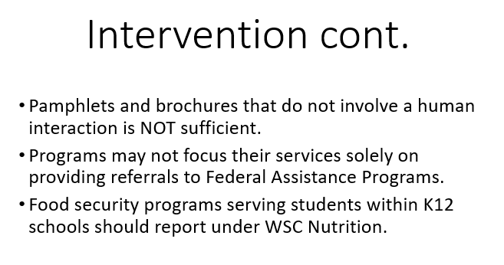
Service requires an engagement with the individual in person, by phone, or through a web-interface. Pamphlets and brochures that do not involve a human interaction is NOT sufficient.

Since this outcome measure is specifically about long-term food security, so it would not apply to summer programs that are filling a summer gap. Filling a summer gap would not translate to increased food security a few months out. If you are a summer program working on this issue, you should create your own applicant-determined measure. Also, this intervention should not be limited to activities that are educational in nature.

Programs may not focus their services solely on providing referrals to Federal assistance programs.
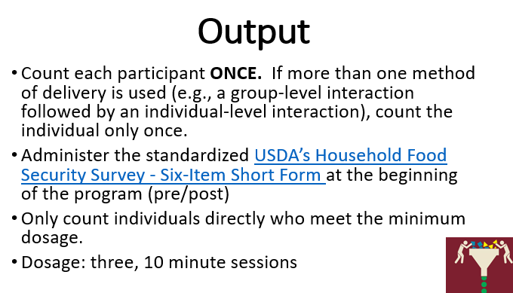
At the outset of the activity, the program should indicate the “dosage,” or how many sessions, days or hours of the service are required to influence low food security. Only count clients who received some minimum “dosage” of at least three, 10 minute session that can be expected to have some effect in terms of alleviating hunger.

The measure the effectiveness of the intervention us a Pre/post” questionnaire. The same questionnaire would be administered to the adult family member at the beginning of the education/training program. The questionnaire would ask about the food security of the adults and children in the household. Ideally, same questionnaire would be administered three to six months after completion of the education/training.

The pre-Survey responses should be analyzed to calculate the number and percent of respondents who reported being food insecure prior to receiving the service. Each individual should be surveyed only once regardless of the number or type of different services (e.g., education/training, counseling) received during the year.

USDA’s Household Food Security Survey - Six-Item Short Form

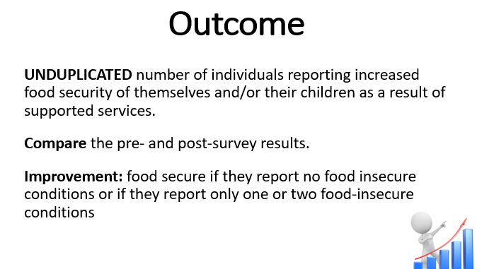
UNDUPLICATED number of individuals reporting increased food security of themselves and/or their children as a result of supported services.

Compare the pre- and post-survey results.

Improvement: food secure if they report no food insecure conditions or if they report only one or two food-insecure conditions. Ideally, the post follow-up survey should be administered at least three to six months after completion of the education/training.

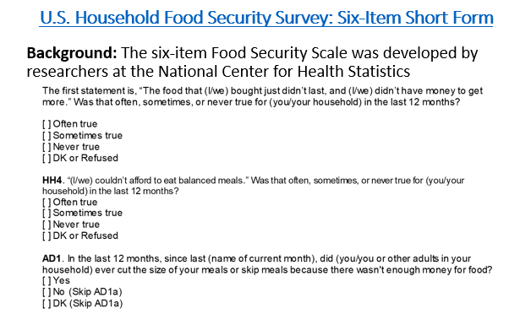
The six item survey is Used to identify food-insecure households and households with very low food security with reasonably high specificity and sensitivity and minimal bias. It does not, however, directly ask about children’s food security, and does not measure the most severe range of adult food insecurity, in which children’s food intake is likely to be reduced. Although, I don’t show all of the specific questions, individuals are classified as food insecure if they report three or more food-insecure conditions. Food-insecure conditions are indicated by responses of “often” or sometimes.
